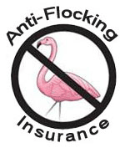
Anti-Flocking
Insurance

The Purchase of this Anti-Flocking Insurance guarantees that no flock of flamingos will roost on my lawn as they migrate around the city during the course of this BAYOU VISTA YOUTH GROUP fundraising event.
The Cost of this Insurance requires a Premium of Only $10.

Policy Holder Name:

Policy Holder Address:

Thank You For Your Support !

Sold By: _________________________

